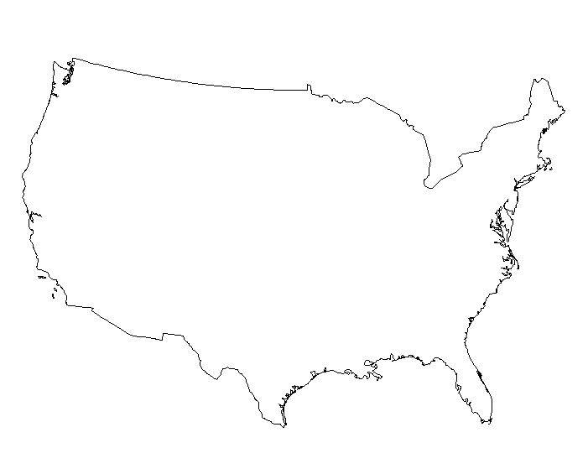
Name:_________________________
Hour:_________________

Need to put Headers on this page for North & South sections

