1.Translate the following from English into Morse code. Remember to place / line between each word
SOS
YOLO
Et tu, Brute
42 Wallaby Way
Keep calm and carry on
2.Translate the following from Morse code to English:
.-- .... .- - / .... .- - .... / --. --- -.. / .-- .-. --- ..- --. .... –
Translates to:
__ __ __ __ / __ __ __ __ / __ __ __ / __ __ __ __ __ __ __

.-. . -- . -- -... . .-. / - .... . / .- .-.. .- -- ---
Translates to:
__ __ __ __ __ __ __ __ / __ __ __ / __ __ __ __ __
-- .- ... ... / .--. .-. --- -.. ..- -.-. - .. --- -.
Translates to:
__ __ __ __ / __ __ __ __ __ __ __ __ __ __
3.You moved to Chicago in 1848 to make your fortune. It is now 1852 and you are very prosperous. You have your own small hat shop and business is very good. All of your family still lives in Philadelphia, Pennsylvania. You have big news to tell your family about your life in Chicago. Write them a telegram telling them your big news: Be sure to fill out the telegram form completely & remember to write “STOP” at the end of each sentence and “END” at the end of the message.
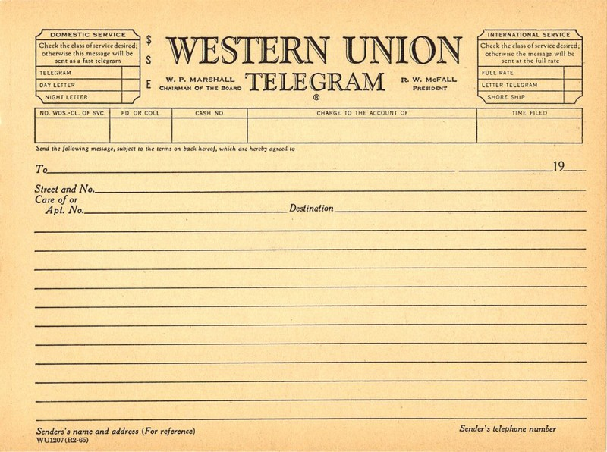
At 5 cents a letter how much will your telegram cost?

X .05_

$.5 per letter
18

