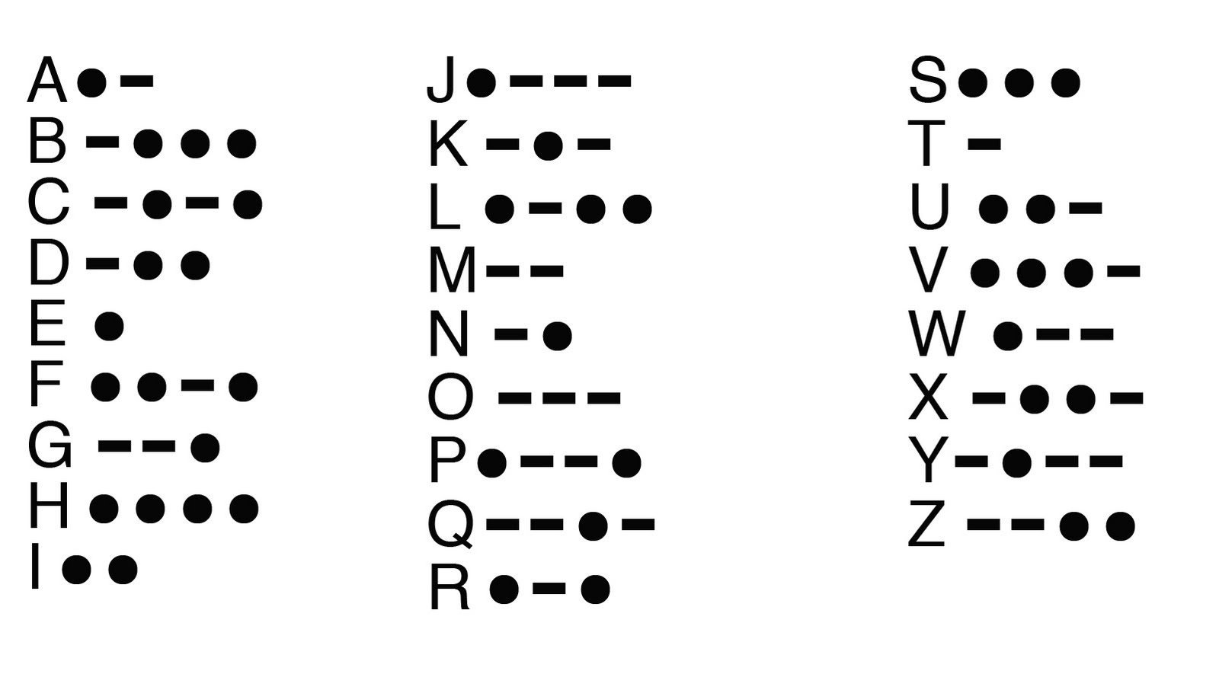
INTERNATIONAL MORSE CODE

INTERNATIONAL MORSE CODE

